

DEPARTMENT OF HEALTH AND CLINICAL OUTCOMES RESEARCH
HDS 5310-03 Analytics and Statistical Programming – (Spring 2024) Prof. Dr. Jason Doherty
Date: 05.02.2024
Project title: THE IMPACT OF SLEEP QUALITY AND DURATION ON DEPRESSIVE SYMPTOMS

TEAM MEMBERS:
BANDHAVYA KODURU
CHERISHMA SAMALA
PRAKRITA KRISHNA
SAISNEHANJALI SANIKE
VARSHA REDDY VEERATI

RESEARCH QUESTION
How do inadequate sleep hours affect mental health symptoms like depression?
BACKGROUND
Insufficient sleep disrupts circadian rhythms in modern lifestyles, increasing the risk of mood disorders like depression and anxiety, worsening mental health challenges, and impairing cognitive function.^{1,2} A third of American adults report sleeping less than recommended, and about 20% have a mental illness.³ Understanding how inadequate sleep hours impact depression symptoms is crucial for informing preventive measures and interventions, potentially reducing the burden of depression, and offering insights into personalized treatment approaches and early intervention strategies to improve mental health outcomes.
In our project, we integrate sleep disorder data and mental health data to evaluate how sleep hours influence mental health using questionnaire data. We assess the impact of different variables, such as gender, age, and marital status, on sleep hours. Subsequently, we analyze how these sleep hours, as influenced by these variables, affect mental health. This multi-faceted approach allows us to examine the complex interplay between sleep patterns and mental health outcomes across different demographic groups, providing a unique perspective on the relationship between these factors.
We plan to use NHANES 2017-2018 data by merging three datasets: demographics, sleep disorders, and mental health screener data. Our dependent variable will be "feeling depressed" from the mental health screener data. Independent variables include age, gender, marital status, and race from demographics data, as well as sleeping hours on weekdays and weekends and trouble sleeping from sleep disorders data. We aim to assess how these factors influence sleep and, consequently, mental health. The Independent variables are common variables explored in mental health research. However, the specific combination of variables and the focus on "feeling depressed" as an outcome may provide a unique perspective on this research.
Research on the relationship between inadequate sleep and mental health, particularly depressive symptoms, holds significant implications for public health, clinical practice, and policy changes.⁴ By identifying a link between sleep quality and depression, the research can guide early interventions and preventive measures, promoting healthy sleep habits and reducing depressive symptoms.^{6,7,8} Clinicians can assess sleep patterns during mental health evaluations to create comprehensive treatment plans. The research may also drive policy changes to promote adequate sleep-in work and education settings.⁹ Additionally, understanding sleep's effects on different demographics can lead to personalized interventions. Advances in sleep monitoring technology may be inspired, while improved sleep can boost productivity, safety, and social dynamics. Emphasizing sleep as a key component of preventive healthcare could help decrease depression and other mental health issues.
In conclusion, our integrated approach combining data from sleep disorders and mental health provides a comprehensive understanding of how insufficient sleep affects depressive symptoms in all populations. Using data from NHANES 2017-2018 and the “depressed feeling” outcome, we explain the complex relationship between sleep patterns and mental health. This study informs early intervention, promotes healthy sleep habits and reduces symptoms of depression. Clinicians can adjust treatment plans by assessing sleep patterns, while decision-makers can support adequate sleep at work and in education. Individualized interventions can be developed for population groups and sleep monitoring technology can be developed. Prioritizing sleep-in preventive health care increases productivity, safety and social well-being.

METHODOLOGY
Descriptive Statistics:
The dataset contains a total of 8 columns with 5030 participants. In this cohort, a majority (51.2%) being female. The average age is 49.55 years old, with a standard deviation of 18.49 years. In terms of race/ethnicity, the largest groups are Non-Hispanic White (35.4%), Non-Hispanic Black (23.0%), and Mexican American (13.8%). Regarding marital status, half (50.1%) are married, while 17.9% have never been married. On average, participants report sleeping 7.59 hours on weekdays and 8.27 hours on weekends. Most (72.0%) do not have trouble sleeping. As for depression, a majority (76.0%) report not feeling depressed at all, though 16.4% felt depressed for several days and smaller percentages felt depressed more frequently.
Table 1: Participant’s demographics on sleep and mental health with 5030 participants from 2017-2018 NHANES survey
 | Overall
n | 5030
Gender = Female (%) | 2575 (51.2)
Age (mean (SD)) | 49.55 (18.49)
Race (%)
Mexican American | 695 (13.8)
Other Hispanic | 455 (9.0)
Non-Hispanic White | 1782 (35.4)
Non-Hispanic Black | 1159 (23.0)
Other Race | 939 (18.7)
mstatus (%)
Married | 2395 (50.1)
Widowed | 357 (7.5)
Divorced | 550 (11.5)
Separated | 175 (3.7)
Never Married | 858 (17.9)
Living with partner | 447 (9.3)
Sleep_hours_on_weekdays (mean (SD)) | 7.59 (1.64)
Sleep_hours_on_weekend (mean (SD)) | 8.27 (1.75)
Trouble_sleeping = No (%) | 3620 (72.0)
Feeling_depressed (%)
Not at all | 3824 (76.0)
Several days | 825 (16.4)
More than half the days | 222 (4.4)
Nearly every day | 159 (3.2)

Data Visualization:
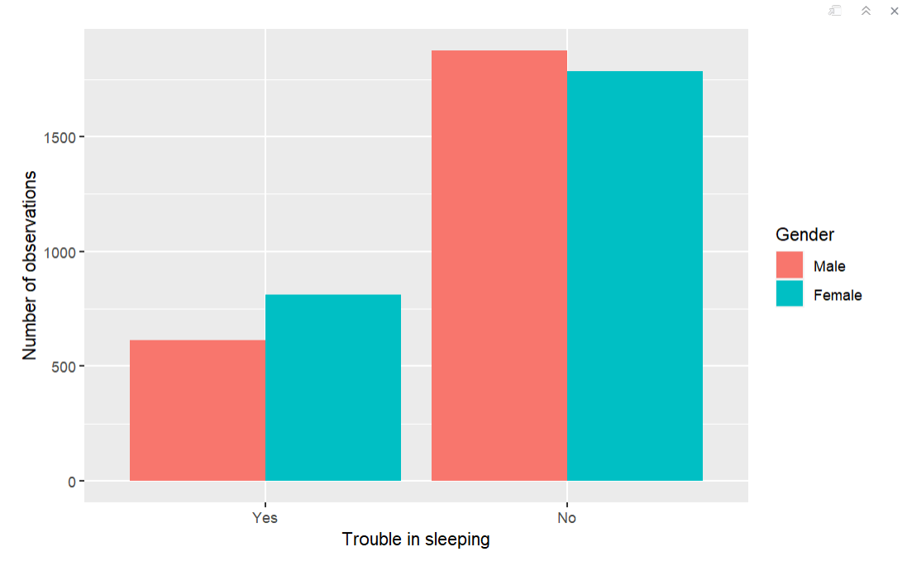
Figure 1: presents the distribution of trouble sleeping by feeling depressed. This plot helps us understand the relationship between sleep difficulties and depression.
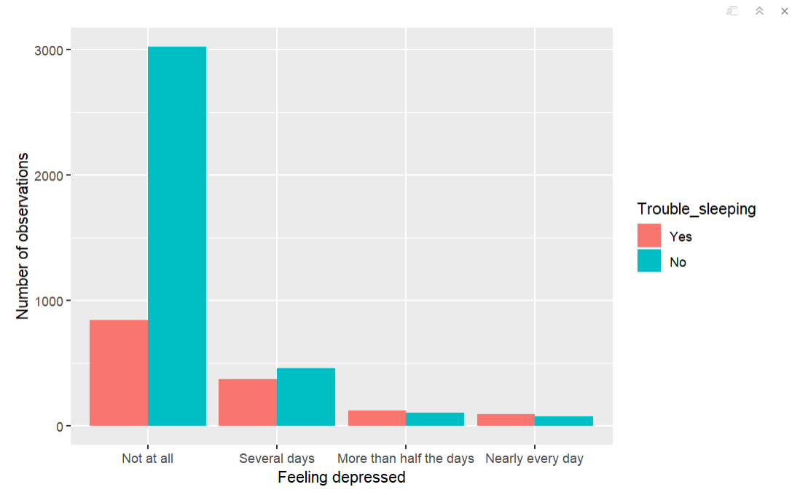
Figure 2: presents the distribution of feeling depressed by trouble sleeping. This plot helps us understand the relationship between sleep difficulties and depression.
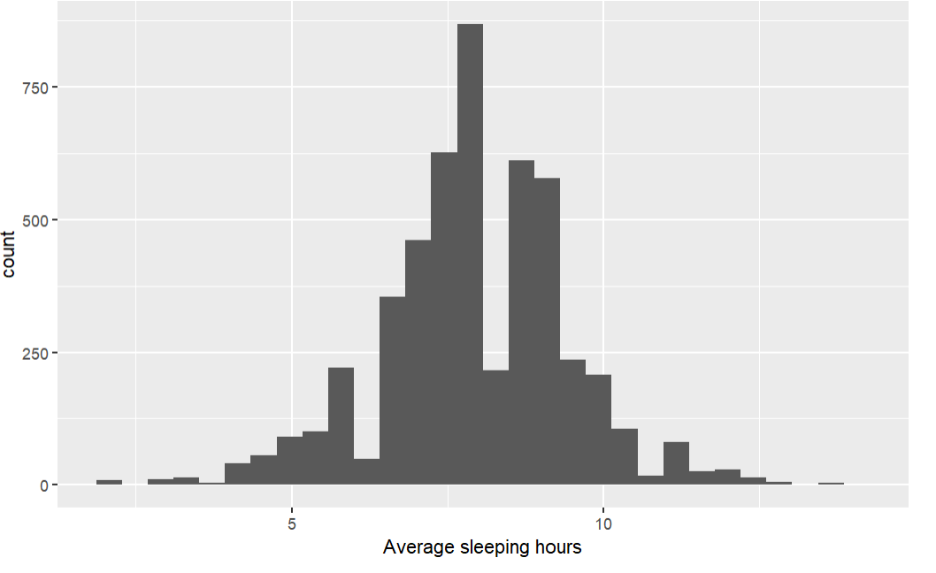 Figure3: The histogram provides a visual representation of the distribution of average sleep hours in the dataset, highlighting the most common range of sleep duration and the skewness of the distribution towards shorter sleep times.
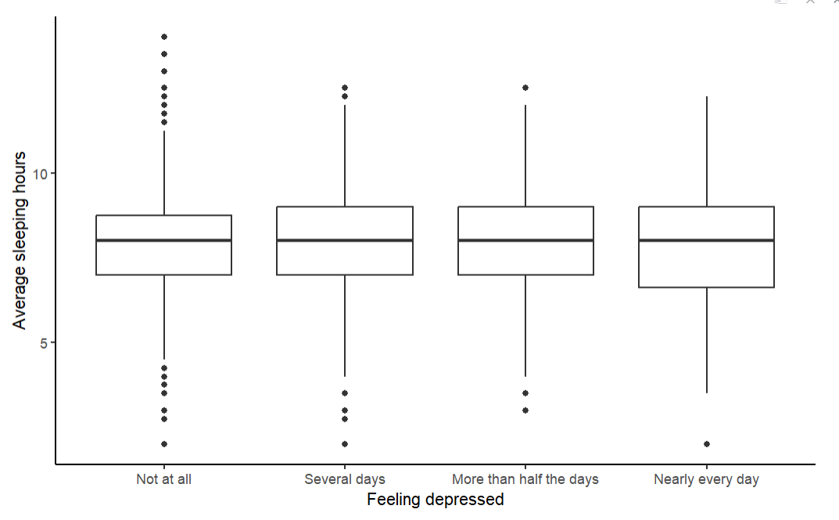
Figure 4: Specifically, the key points about the boxplot are:
- The x-axis represents the different levels of feeling depressed: "Not at all", "Several days", "More than half the days", and "Nearly every day".
- The y-axis shows the average sleeping hours.
In summary, the boxplot clearly demonstrates a trend where increased frequency of feeling depressed is associated with lower median average sleeping hours and greater variability in sleep patterns. This suggests a potential relationship between depression and sleep disturbances, where individuals experiencing more frequent depressive symptoms tend to have fewer average sleeping hours.
Data Management:
Based on the descriptive statistics and visualizations, the following data management steps were taken:
1. Checked for missing values and handled them appropriately. Specifically, rows with missing values for "Trouble Sleeping" and "Gender" were dropped, as these variables are key to the analysis.
2. Converted the "Gender" and "Feeling Depressed" variables to factors to treat them as categorical variables in the statistical tests.
3. Checked the assumptions (normality, homogeneity of variance) for the ANOVA and t-test analyses.
Statistical Tests and Methods:
1. Chi-Square Test
Assumptions:
- The variables are nominal or ordinal.
- The expected values in each cell are greater than 5.
- The observations are independent.
- Gender and Feeling Depressed: Previous research suggest that depression rates may differ by gender, with women possibly experiencing higher rates of depression than men. This variation could be influenced by social, biological, or environmental factors, highlighting the importance of examining these differences in our sample.
- (H0): There is no association between gender and feeling depressed.
- (HA): There is an association between gender and feeling depressed.
The variables chosen, met the above assumptions and hence we conducted the Chi-square test and got a p value < 0.05. We found it to be statistically significant and concluded that there is an association between gender and feeling depressed. [^{χ2}(3) = 40.768; p < .05]. Since it was statistically significant, we conducted a post-hoc test using cross table function and further, we measured the effect size using Cramer’s V statistic to interpret the strength of the significant Chi-squared relationship and found it to be weak having a value of 0.09.
- Feeling Depressed and Trouble Sleeping: The relationship is bidirectional trouble sleeping may contribute to the development of depression, and depression can lead to sleep disturbances. Hence, we have chosen the variables to test.
- (H0): There is no association between feeling depressed and trouble sleeping.
- (HA): There is an association between feeling depressed and trouble sleeping.
We conducted the Chi-square test and got a p value < 0.05. We found it to be statistically significant and concluded that there is an association between gender and feeling depressed. [^{χ2}(3) = 311.26; p < .05]. Since it was statistically significant, we conducted a post-hoc test using cross table function and further we measured the effect size using Cramer’s V statistic to interpret the strength of the significant Chi-squared relationship was found to be weak to moderate with a value of 0.24.
2. One -way ANOVA Test
Assumptions:
Having a continuous outcome and independent groups, independent observations, an outcome that is normally distributed within groups, and equal variance of the outcome within groups.
- Average Sleep hours and Gender: Surveys have suggested that sleep patterns can vary by gender, with some studies indicating that women may have different sleep requirements due to biological & hormonal factors.
- H0: There is no association between sleep hours and gender.
- HA: There is an association between sleep hours and gender.
The assumptions were met and we conducted ANOVA test to compare the relationship of our independent variables average sleep hours across gender, which is categorical. To compare the means of sleep hours across sleep hours and gender groups we wished to run an Analysis of Variance (ANOVA). To verify the normality and variance of the variables, we conducted the Shapiro Wilk test and Levene test accordingly and found it to be significant. In addition, to examine which group means are significantly different, we aimed to perform post-hoc tests such as Tukey’s HSD test, and to estimate the effect size or strength of the relationship between sleep hours and gender groups we used the omega-squared size effect.

- Feeling Depressed and Average Sleep hours: Changes in average sleep hours may impact mood and emotional well-being, potentially contributing to symptoms of depression. Hence, we use these variables for testing.
- (H0): There is no association between feeling depressed and average sleep hours.
- (HA): There is an association between feeling depressed and trouble sleep hours.
The assumptions were met, and we conducted ANOVA test to compare the relationship of our independent variables feeling depressed across average sleep hours, which is categorical. To compare the means of sleep hours across sleep hours and gender groups we wished to run an Analysis of Variance (ANOVA). To verify the normality and variance of the variables, we conducted the Shapiro Wilk test and Levene test accordingly and it failed the test of variance. As an alternative to ANOVA, we conducted a Kruskal-Wallis test and found it to be insignificant. Since we retain the null hypothesis, there was no requirement of post-hoc test.
Final Model:
A statistically significant logistic regression model was used to examine the factors associated with feeling depressed, including gender, age, race, marital status, trouble sleeping, and average sleep hours. The logistic regression model was statistically significant [^{χ2}(13) = 410.778, p < .001], indicating that the model containing the predictors was better at predicting feeling depressed than the baseline probability.
The model provided valuable insights into the factors associated with the likelihood of feeling depressed. Being female increased the odds of feeling depressed by 29% compared to males. Certain racial groups, such as Other Hispanic, had higher odds of depression, while non-Hispanic Black individuals had lower odds. Marital statuses like being widowed, divorced, or separated were associated with a higher likelihood of depression, with separated individuals having more than double the odds compared to those who were not separated. Trouble sleeping was a strong predictor of depression, with those without trouble sleeping having 68% lower odds of feeling depressed. Age and average sleep hours were not significant predictors of feeling depressed.
The model correctly classified 76% of the cases, and the Adjusted Count R-squared indicated a 3% improvement in correct predictions over the baseline. These findings highlight the importance of addressing gender, racial, and marital status differences, as well as the strong link between sleep difficulties and depression, in order to improve mental health outcomes.
Results Discussion and Conclusion:
The chi-square test of independence revealed a statistically significant association between gender and feeling depressed and the other variable feeling depressed and trouble sleeping. The standardized residuals suggest that males are more likely to report not feeling depressed, while females are more likely to report feeling depressed for several days or more than the days. The results show that individuals who report feeling depressed are more likely to experience trouble sleeping than those who do not feel depressed. The ANOVA test showed that there was a significance difference in sleep hours across different gender groups.
The Kruskal-Wallis test did not find a significant difference in average sleep hours among the different levels of feeling depressed. This suggests that feeling depressed is not associated with the average number of sleep hours.
The logistic regression model was statistically significant [^{χ2}(13) = 410.778, p < .001], indicating that the model containing the predictors was better at predicting feeling depressed than the baseline probability. The model correctly classified 76% of the cases.
The results show that being female increases the odds of feeling depressed by 29% compared to males. Certain racial groups, such as Other Hispanic, also have higher odds of depression, while non-Hispanic Black individuals have lower odds. Marital statuses like being widowed, divorced, or separated are associated with a higher likelihood of depression, with separated individuals having more than double the odds compared to those who are not separated. Trouble sleeping is a strong predictor of depression, with those without trouble sleeping having 68% lower odds of feeling depressed.
These findings have practical significance, as they highlight the importance of addressing gender, racial, and marital status differences in depression, as well as the strong link between sleep difficulties and depression. Targeted interventions and support services may be needed to address these disparities and improve mental health outcomes.

Limitations:
Missing Variables: The study may not have included all relevant variables that could influence the relationship between sleep patterns and depression. For instance, factors like socioeconomic status, employment status, physical health conditions, or medication use could impact both sleep and mental health outcomes.
Sample Representation: The sample may not be fully representative of the population due to potential selection biases or underrepresentation of certain demographic groups. This could affect the generalizability of the findings to the broader population.

REFERENCES:
1)Franzen PL, Buysse DJ. Sleep disturbances and depression: risk relationships for subsequent depression and therapeutic implications. Dialogues in Clinical Neuroscience. 2008;10(4):473-481. doi:10.31887/dcns.2008.10.4/plfranzen

2) Kalmbach DA, Cuamatzi-Castelan AS, Tonnu CV, et al. Hyperarousal and sleep reactivity in insomnia: current insights. Nat Sci Sleep. 2018;10:193-201. Published 2018 Jul 17. doi:10.2147/NSS.S138823
3) Blackwelder AJ, Hoskins M, Huber LRB. Effect of inadequate sleep on frequent mental distress. Preventing Chronic Disease. 2021;18. doi:10.5888/pcd18.200573

4)Alotaibi AD, Alosaimi F, Alajlan AA, Abdulrahman K a. B. The relationship between sleep quality, stress, and academic performance among medical students. Journal of Family and Community Medicine/Maǧalaẗ Ṭib Al-usraẗ Wa Al-muǧtamaʼ. 2020;27(1):23. doi:10.4103/jfcm.jfcm_132_19

5)Sabia S, Fayossé A, Dumurgier J, et al. Association of sleep duration in middle and old age with incidence of dementia. Nature Communications. 2021;12(1). doi:10.1038/s41467-021-22354-2

6) Fernandez‐Mendoza J, Vgontzas AN. Insomnia and its Impact on Physical and Mental Health. Current Psychiatry Reports/Current Psychiatry Reports. 2013;15(12). doi:10.1007/s11920-013-0418-8

7) Corbo I, Forte G, Favieri F, Casagrande M. Poor Sleep Quality in Aging: The Association with Mental Health. International Journal of Environmental Research and Public Health/International Journal of Environmental Research and Public Health. 2023;20(3):1661. doi:10.3390/ijerph20031661

8)Benca RM, Peterson MJ. Insomnia and depression. Sleep Med. 2008;9 Suppl 1:S3-S9. doi:10.1016/S1389-9457(08)70010-8

9) Afonso P, Fonseca M, Pires JF. Impact of working hours on sleep and mental health. Occupational Medicine. 2017;67(5):377-382. doi:10.1093/occmed/kqx054

